CODE | OUTPUT
<!DOCTYPE html>  <html lang="en">  <head>  <meta charset="UTF-8">  <meta name="viewport" content="width=device-width, initial-scale=1.0">  <title>Facebook Login Page</title>  <style>  * {  margin: 0;  padding: 0;  box-sizing: border-box;  font-family: Arial, sans-serif;  }  body {  background-color: white;  }  .container {  display: flex;  min-height: 96vh;  }  /* LEFT SIDE */  .left {  width: 57%;  position: relative;  border-right: 2px solid #ddd;  display: flex;  align-items: center;  padding: 40px;  overflow: hidden;  }  .logo {  position: absolute;  top: 45px;  left: 48px;  background: #0866ff;  color: white;  width: 64px;  height: 64px;  border-radius: 50%;  font-size: 66px;  font-weight: bold;  text-align: center;  line-height: 78px;  overflow: hidden;  }  .heading {  font-size: 62px;  line-height: 1.1;  letter-spacing: -2px;  color: #111;  z-index: 2;  margin-top: 170px;  }  .heading span {  color: #0866ff;  }  /* PICTURES */  .pictures {  position: absolute;  width: 56%;  height: 76%;  top: 9%;  left: 38%;  }  .pic {  position: absolute;  object-fit: cover;  border-radius: 20px;  border: 7px solid white;  box-shadow: 0 3px 15px #00000020;  }  .pic1 {  width: 57%;  height: 72%;  right: 5%;  top: 0;  z-index: 2;  }  .pic2 {  width: 56%;  height: 43%;  left: 0;  top: 24%;  z-index: 1;  }  .pic3 {  width: 58%;  height: 46%;  left: 12%;  bottom: 0;  z-index: 3;  }  .smile {  position: absolute;  top: 7%;  left: -5%;  font-size: 48px;  z-index: 4;  }  .heart {  position: absolute;  right: -1%;  top: 52%;  background: #ff1764;  color: white;  border-radius: 50%;  width: 65px;  height: 65px;  text-align: center;  line-height: 65px;  font-size: 35px;  z-index: 4;  }  .time {  position: absolute;  top: 10%;  right: 0;  background: #6b5ce7;  color: white;  padding: 10px 15px;  border-radius: 15px;  z-index: 4;  }  /* RIGHT SIDE */  .right {  width: 43%;  display: flex;  align-items: center;  justify-content: center;  padding: 40px;  }  .login-box {  width: 100%;  max-width: 575px;  }  .login-box h2 {  font-size: 17px;  font-weight: 600;  margin-bottom: 26px;  }  .login-box input {  display: block;  width: 100%;  height: 64px;  border: 1px solid #d0d0d0;  border-radius: 17px;  padding: 0 17px;  margin-bottom: 12px;  font-size: 16px;  outline: none;  }  .login-box input:focus {  border-color: #0866ff;  }  .login-button {  width: 100%;  height: 48px;  border: none;  border-radius: 25px;  background: #0866ff;  color: white;  font-size: 16px;  font-weight: bold;  cursor: pointer;  margin-top: 12px;  }  .forgot {  display: block;  text-align: center;  color: #111;  text-decoration: none;  margin-top: 25px;  margin-bottom: 68px;  font-size: 16px;  }  .create-button {  width: 100%;  height: 48px;  border: 1px solid #0866ff;  border-radius: 25px;  background: white;  color: #0866ff;  font-size: 16px;  cursor: pointer;  }  .meta {  text-align: center;  margin-top: 25px;  font-size: 16px;  color: #444;  }  .meta span {  font-size: 23px;  font-weight: bold;  color: #0866ff;  }  /* MOBILE SCREEN */  @media (max-width: 850px) {  .container {  flex-direction: column;  }  .left, .right {  width: 100%;  }  .left {  min-height: 430px;  border-right: none;  border-bottom: 1px solid #ddd;  }  .heading {  font-size: 42px;  }  .pictures {  left: 42%;  width: 55%;  }  .right {  padding: 35px 20px;  }  .forgot {  margin-bottom: 40px;  }  }  </style>  </head>  <body>  <div class="container">  <!-- LEFT SIDE -->  <div class="left">  <div class="logo">f</div>  <h1 class="heading">  Explore<br>  the<br>  things<br>  <span>you love.</span>  </h1>  <div class="pictures">  <img  class="pic pic1"  src="https://images.unsplash.com/photo-1534528741775-53994a69daeb?w=600"  alt="Portrait of a woman">  <img  class="pic pic2"  src="https://images.unsplash.com/photo-1501004318641-b39e6451bec6?w=600"  alt="Green plants">  <img  class="pic pic3"  src="https://images.unsplash.com/photo-1520045892732-304bc3ac5d8e?w=600"  alt="Skate park">  <div class="smile">😆</div>  <div class="time">◷ 16:45</div>  <div class="heart">♥</div>  </div>  </div>  <!-- RIGHT SIDE -->  <div class="right">  <div class="login-box">  <h2>Log in to Facebook</h2>  <form onsubmit="return false;">  <input  type="text"  placeholder="Email address or mobile number">  <input  type="password"  placeholder="Password">  <button class="login-button" type="submit">  Log in  </button>  </form>  <a href="#" class="forgot"  onclick="return false;">  Forgotten password?  </a>  <button class="create-button" type="button">  Create new account  </button>  <div class="meta">  <span>∞</span> Meta  </div>  </div>  </div>  </div>  </body>  </html> | 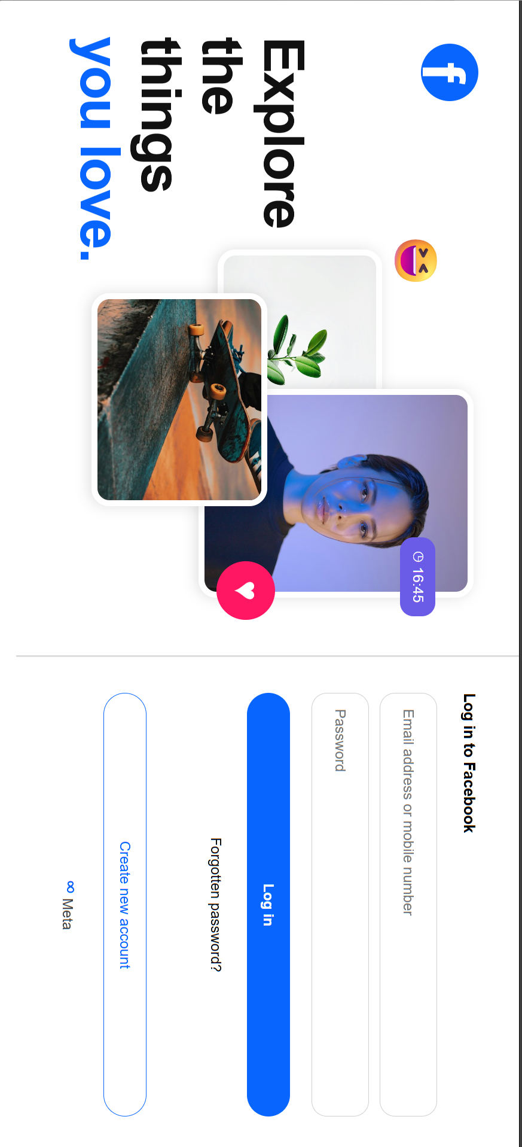
Facebook page done
CODE | OUTPUT
<!DOCTYPE html>  <html lang="en">  <head>  <meta charset="UTF-8">  <meta name="viewport" content="width=device-width, initial-scale=1.0">  <title>Instagram Login Page</title>  <style>  * {  margin: 0;  padding: 0;  box-sizing: border-box;  font-family: Arial, sans-serif;  }  body {  background: white;  color: #171717;  }  .container {  display: flex;  min-height: 92vh;  }  /* LEFT SIDE */  .left {  width: 67.3%;  min-height: 700px;  position: relative;  border-right: 2px solid #e5e5e5;  overflow: hidden;  }  .instagram-logo {  position: absolute;  top: 35px;  left: 35px;  width: 47px;  height: 47px;  border: 4px solid #d62976;  border-radius: 13px;  }  .instagram-logo::before {  content: "";  position: absolute;  width: 19px;  height: 19px;  border: 3px solid #ee2a7b;  border-radius: 50%;  top: 9px;  left: 9px;  }  .instagram-logo::after {  content: "";  position: absolute;  width: 6px;  height: 6px;  background: #feda75;  border-radius: 50%;  right: 6px;  top: 6px;  }  .heading {  position: absolute;  top: 95px;  left: 30%;  width: 45%;  text-align: center;  font-size: 40px;  line-height: 1.25;  font-weight: 400;  z-index: 5;  }  .heading span {  background: linear-gradient(  90deg,  #f58529,  #dd2a7b,  #8134af  );  -webkit-background-clip: text;  color: transparent;  font-weight: 500;  }  /* PICTURE COLLAGE */  .picture-area {  position: absolute;  width: 440px;  height: 390px;  left: 28%;  top: 37%;  }  .picture {  position: absolute;  object-fit: cover;  border-radius: 25px;  box-shadow: 0 8px 25px #00000020;  background: #eee;  }  .picture-one {  width: 180px;  height: 255px;  left: 10px;  top: 55px;  transform: rotate(-5deg);  z-index: 1;  }  .picture-two {  width: 210px;  height: 365px;  left: 100px;  top: 0;  z-index: 3;  }  .picture-three {  width: 175px;  height: 260px;  left: 245px;  top: 55px;  transform: rotate(5deg);  z-index: 2;  }  .reaction {  position: absolute;  z-index: 4;  font-size: 43px;  }  .heart {  left: -15px;  top: 185px;  }  .stars {  right: 0;  top: 100px;  background: #16c65b;  color: white;  font-size: 20px;  padding: 7px 12px;  border-radius: 20px;  }  .emoji-bar {  position: absolute;  top: 25px;  left: 50px;  z-index: 4;  background: white;  border-radius: 25px;  padding: 8px 12px;  box-shadow: 0 2px 10px #00000020;  }  .profile {  position: absolute;  bottom: 120px;  right: 8px;  z-index: 5;  width: 65px;  height: 65px;  border-radius: 50%;  border: 3px solid #e1306c;  object-fit: cover;  padding: 3px;  background: white;  }  /* RIGHT SIDE */  .right {  width: 32.7%;  display: flex;  justify-content: center;  align-items: center;  padding: 40px;  }  .login-box {  width: 100%;  max-width: 430px;  margin-top: 5px;  }  .login-box h2 {  font-size: 14px;  font-weight: 600;  margin-bottom: 20px;  }  .login-box input {  display: block;  width: 100%;  height: 47px;  padding: 0 13px;  margin-bottom: 10px;  border: 1px solid #dbdbdb;  border-radius: 13px;  font-size: 13px;  outline: none;  background: white;  }  .login-box input:focus {  border-color: #a8a8a8;  }  button {  cursor: pointer;  font-size: 13px;  }  .login-button {  width: 100%;  height: 35px;  margin-top: 8px;  border: none;  border-radius: 20px;  background: #9bc3f5;  color: white;  font-weight: bold;  }  .forgot {  display: block;  text-align: center;  margin: 18px 0 52px;  text-decoration: none;  color: #262626;  font-size: 13px;  }  .facebook-button {  width: 100%;  height: 36px;  border: none;  border-radius: 20px;  background: #f2f3f5;  color: #262626;  margin-bottom: 10px;  }  .facebook-icon {  color: #0866ff;  font-weight: bold;  font-size: 16px;  }  .create-button {  width: 100%;  height: 36px;  border: 1px solid #0866ff;  border-radius: 20px;  background: white;  color: #0866ff;  margin-top: 0;  }  .meta {  text-align: center;  margin-top: 17px;  font-size: 13px;  }  .meta span {  color: #0866ff;  font-size: 20px;  font-weight: bold;  }  /* FOOTER */  footer {  min-height: 55px;  border-top: 1px solid #eee;  display: flex;  flex-wrap: wrap;  justify-content: center;  align-items: center;  gap: 12px;  padding: 15px 10px;  color: #737373;  font-size: 10px;  }  footer a {  text-decoration: none;  color: #737373;  }  .copyright {  width: 100%;  text-align: center;  margin-top: 3px;  }  /* RESPONSIVE DESIGN */  @media (max-width: 950px) {  .left {  width: 55%;  }  .right {  width: 45%;  padding: 25px;  }  .heading {  left: 15%;  width: 75%;  font-size: 32px;  }  .picture-area {  left: 10%;  transform: scale(0.85);  transform-origin: top left;  top: 40%;  }  }  @media (max-width: 650px) {  .container {  min-height: auto;  }  .left {  display: none;  }  .right {  width: 100%;  min-height: 85vh;  padding: 25px;  }  .login-box {  max-width: 400px;  }  footer {  gap: 10px;  }  }  </style>  </head>  <body>  <div class="container">  <!-- LEFT SECTION -->  <section class="left">  <div class="instagram-logo"></div>  <h1 class="heading">  See everyday<br>  moments from your<br>  <span>close friends.</span>  </h1>  <div class="picture-area">  <img  class="picture picture-one"  src="https://images.unsplash.com/photo-1517841905240-472988babdf9?w=500"  alt="Friend">  <img  class="picture picture-two"  src="https://images.unsplash.com/photo-1524504388940-b1c1722653e1?w=600"  alt="Portrait">  <img  class="picture picture-three"  src="https://images.unsplash.com/photo-1529139574466-a303027c1d8b?w=500"  alt="Friend">  <div class="emoji-bar">🟣 👀 🥰 😍</div>  <div class="reaction heart">💗</div>  <div class="reaction stars">★⌄</div>  <img  class="profile"  src="https://images.unsplash.com/photo-1534528741775-53994a69daeb?w=150"  alt="Profile">  </div>  </section>  <!-- RIGHT SECTION -->  <section class="right">  <div class="login-box">  <h2>Log into Instagram</h2>  <form onsubmit="return false;">  <input  type="text"  placeholder="Mobile number, username or email">  <input  type="password"  placeholder="Password">  <button class="login-button" type="submit">  Log in  </button>  </form>  <a href="#" class="forgot"  onclick="return false;">  Forgot password?  </a>  <button class="facebook-button" type="button">  <span class="facebook-icon">f</span>  &nbsp; Log in with Facebook  </button>  <button class="create-button" type="button">  Create new account  </button>  <div class="meta">  <span>∞</span> Meta  </div>  </div>  </section>  </div>  <!-- FOOTER -->  <footer>  <a href="#">Meta</a>  <a href="#">About</a>  <a href="#">Blog</a>  <a href="#">Jobs</a>  <a href="#">Help</a>  <a href="#">API</a>  <a href="#">Privacy</a>  <a href="#">Terms</a>  <a href="#">Locations</a>  <a href="#">Instagram Lite</a>  <a href="#">Threads</a>  <a href="#">Contact Uploading & Non-Users</a>  <a href="#">Meta Verified</a>  <div class="copyright">  English &nbsp; | &nbsp; © 2026 Instagram from Meta  </div>  </footer>  </body>  </html> | 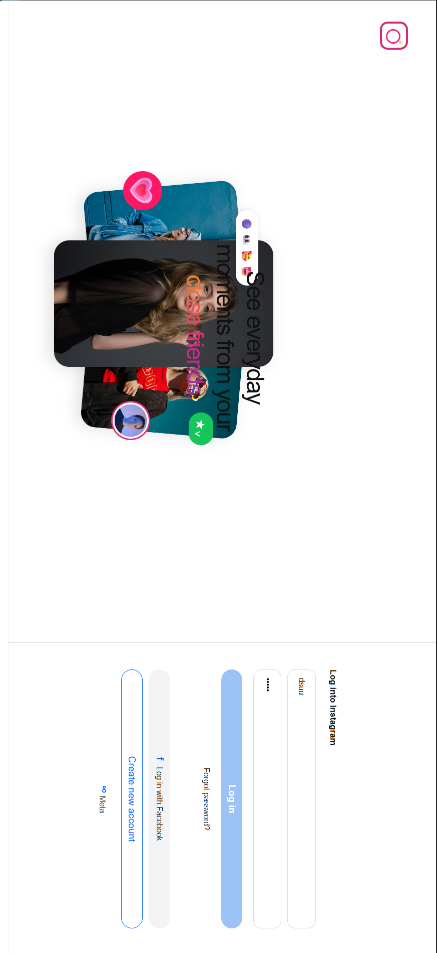
INSTAGRAM PAGE DONE

